|  |  |
| --- | --- |
|  | **BAHRIA UNIVERSITY,**  **(Karachi Campus)**  *Department of Software Engineering*  **Fall 2020** |

COURSE TITLE: **Data Communication and Networking** COURSE CODE: **CEN-222**

Class: **BSE - 5B** Shift:**Morning**

Course Instructor: **Engr. Mahawish Fatima** Date:**06-Oct-2020**

Lab Instructor:**Engr. Fareeha Dilawar**

**OEL-I**

**[CLO#2]**

**Task:** You are the administrator at ciscolab.com.

1. Configure a topology where we have S1,S2,S3 and S4 switches interconnected with one extra port (connection) for backup purposes.

2. Make S2 as the root bridge and show the forwarding and blocking ports with respect to each switch.

3. Transfer the shift now to S4 and make it your primary root, while choosing any other as the secondary root bridge.

4. Using VTP, Add Vlans VLANIT for S2 and S4 and VLANHR for S1 and S3 and test your network.

5. Delete VLANHR from the server switch and show the impact on other switches.

**FOLLOW THE BELOW INSTRUCTIONS:**

* Make sure to answer the questions as per the processes, commands and logics studied in the lab.
* Zero plagiarism means no copying from the internet and from others (the one who will copy and the one who shares both will face the consequences).
* Timely submission is important. failed to do so will lead to 3 marks deduction.
* Screenshots need to be added for each step.

**Good Luck!**

# **Solution:**

1. **Configure a topology where we have S1,S2,S3 and S4 switches interconnected with one extra port (connection) for backup purposes.**

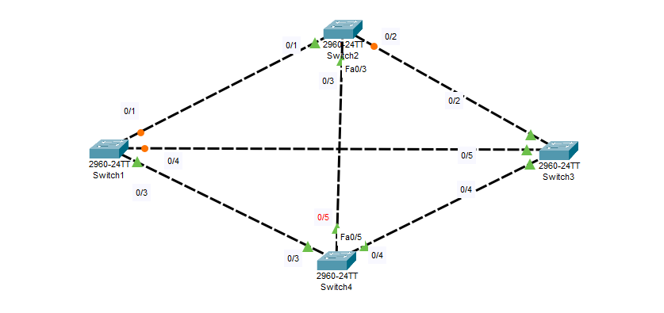

1. **Make S2 as the root bridge and show the forwarding and blocking ports with respect to each switch.**

**First checking root bridge:**

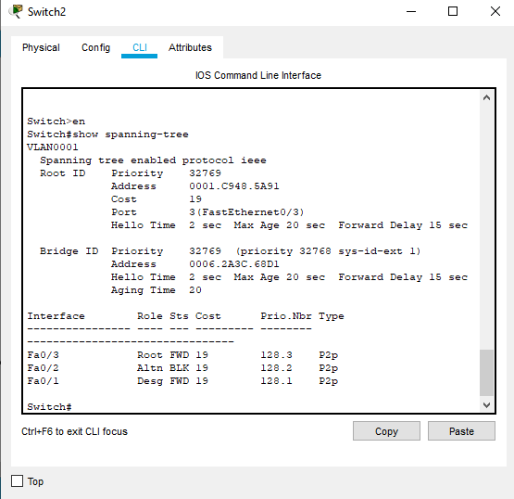

So switch 2 is not my root bridge

Root priority: 32769

Address: 0006.2A3C.68D1

Root port: 0/3

Designation port: 0/1

Blocked: 0/2

Lets make S2 root bridge:

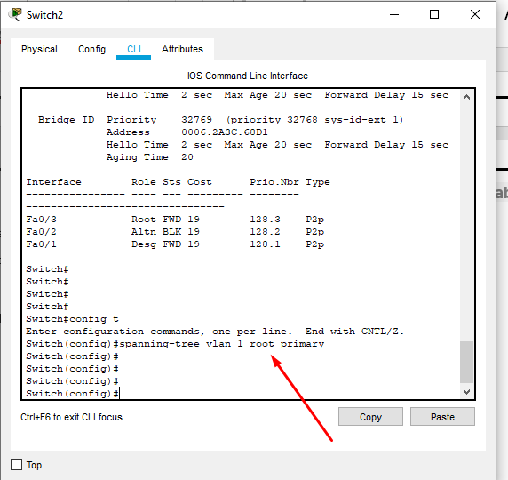

**Proof:**

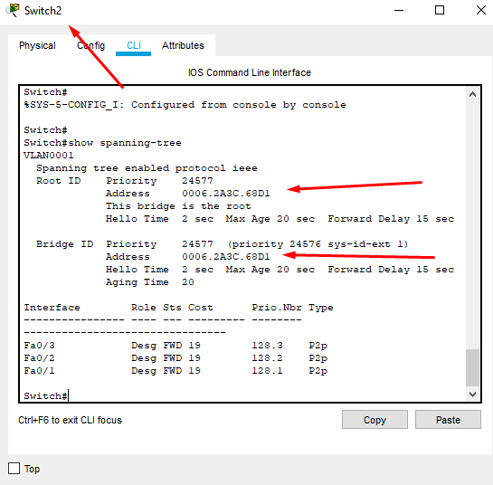

**New Topology:**

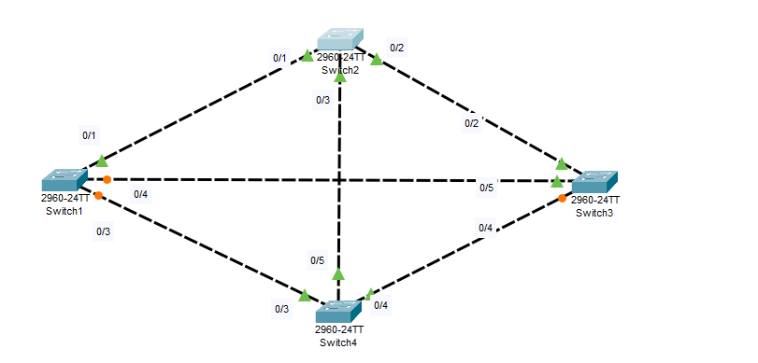**Switch 2:**

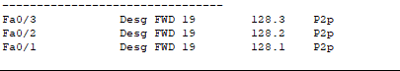

**Switch 1:**

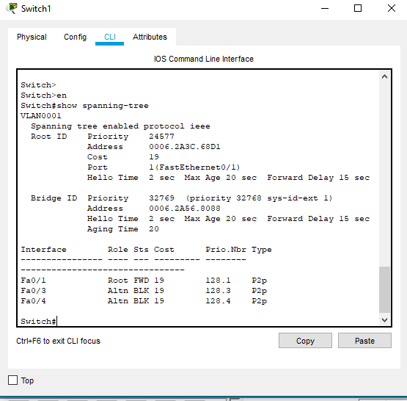

**Switch 3:**

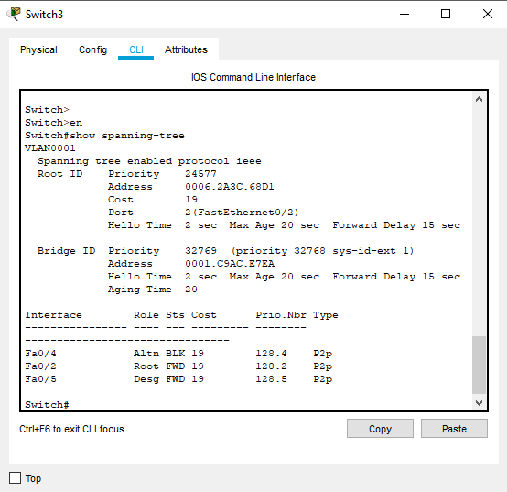

**Switch 4:**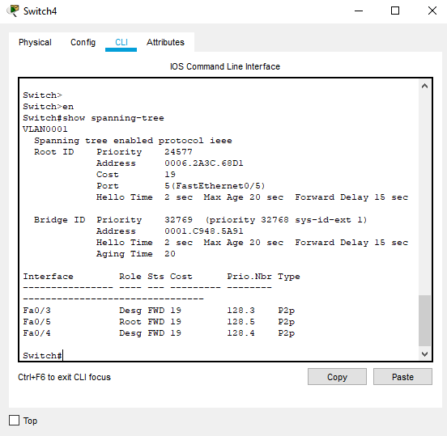

1. **Transfer the shift now to S4 and make it your primary root, while choosing any other as the secondary root bridge.**

**Now switch 4 as per now**



Making it primary root

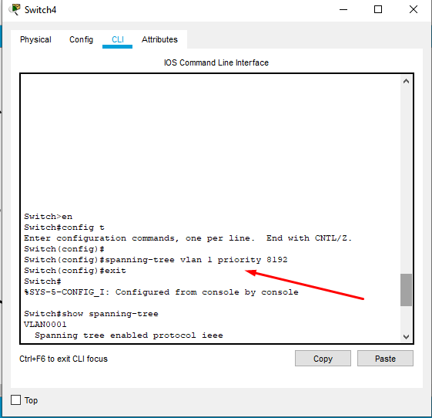

Proof

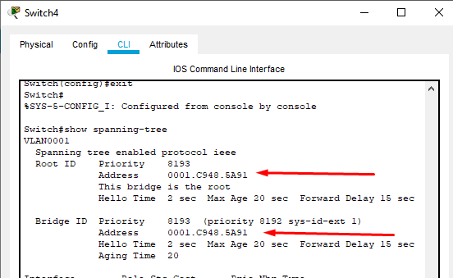

Making Switch1 secondary:

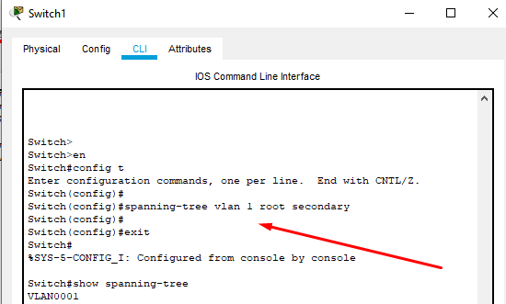

1. **Using VTP, Add Vlans VLANIT for S2 and S4 and VLANHR for S1 and S3 and test your network.**

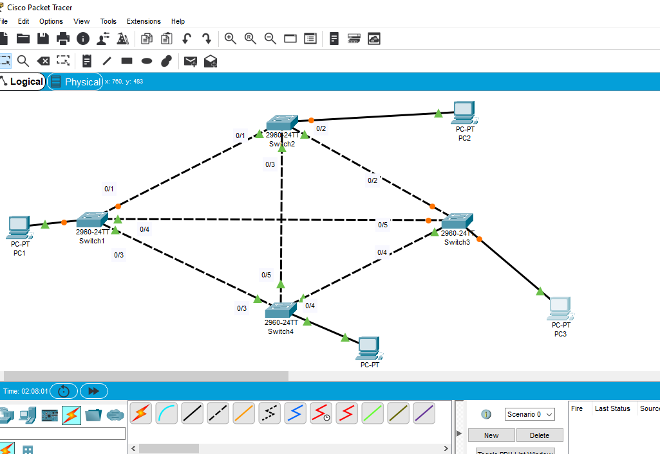

**Switch 1**

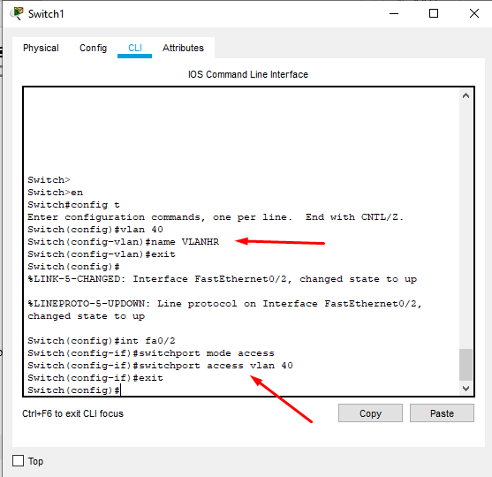

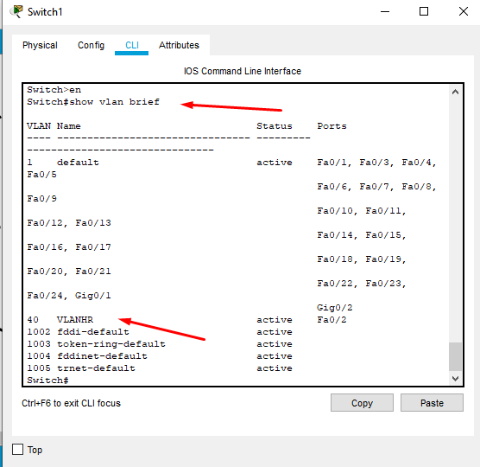

**Switch 3**

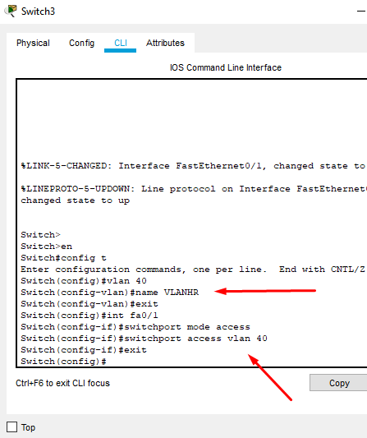

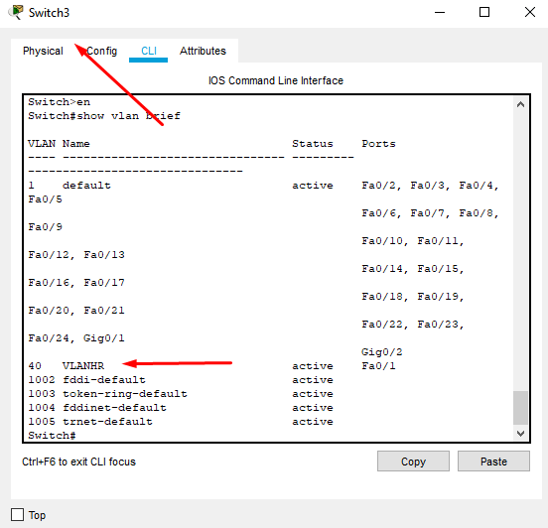

**Switch 2**

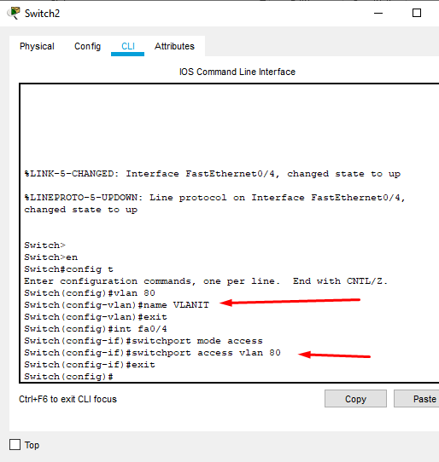

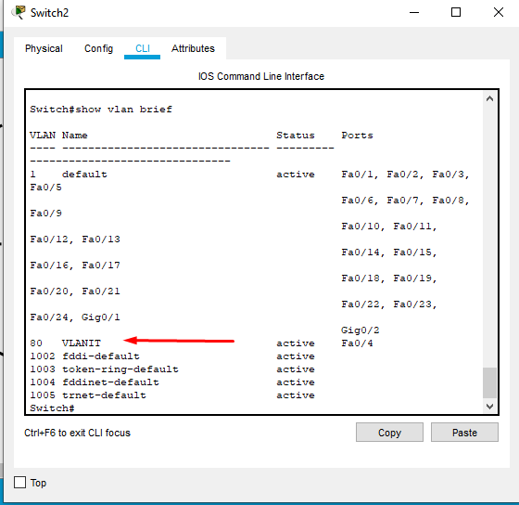

**Switch 4**

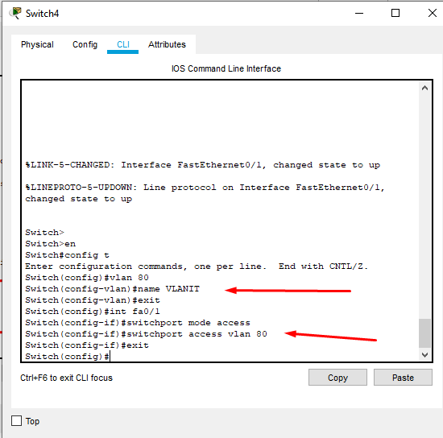

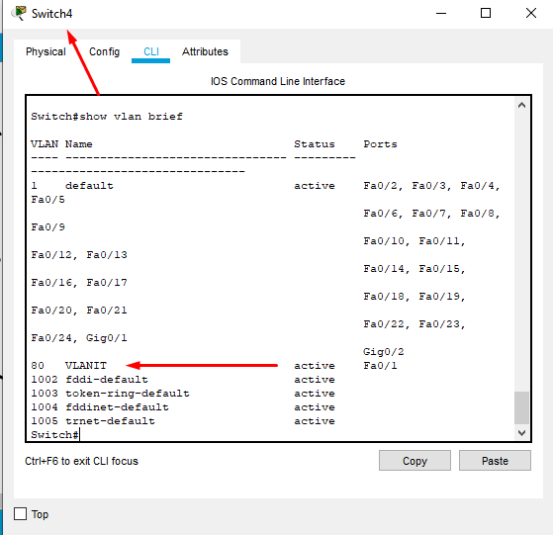

**Now making trunks on all 4 switches**

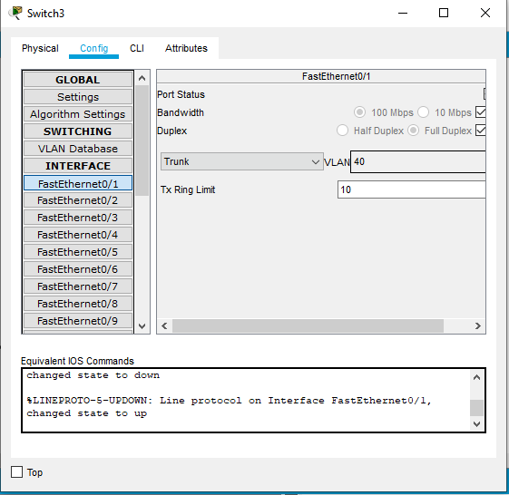

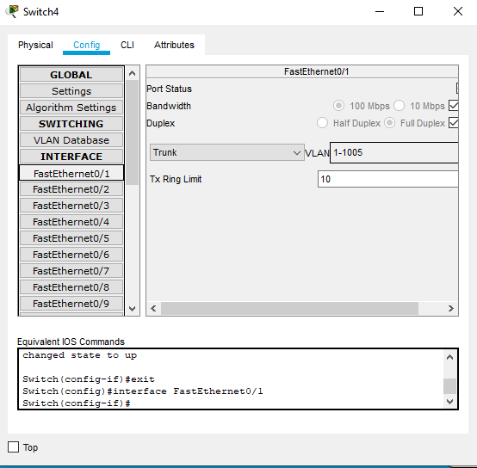

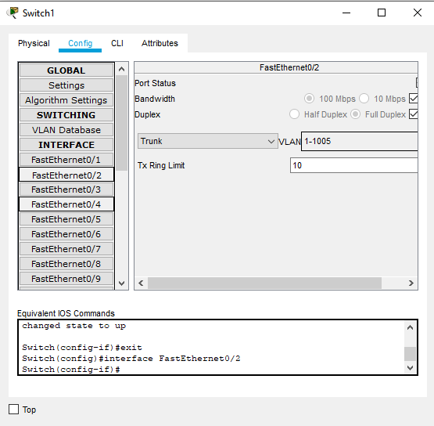

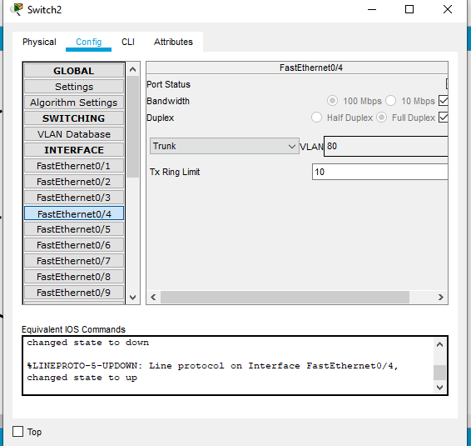

**Pc1 ip: 192.168.22.2**

**Pc2 ip: 192.168.22.4**

**Pc3 ip: 192.168.22.6**

**Pc4 ip: 192.168.22.8**

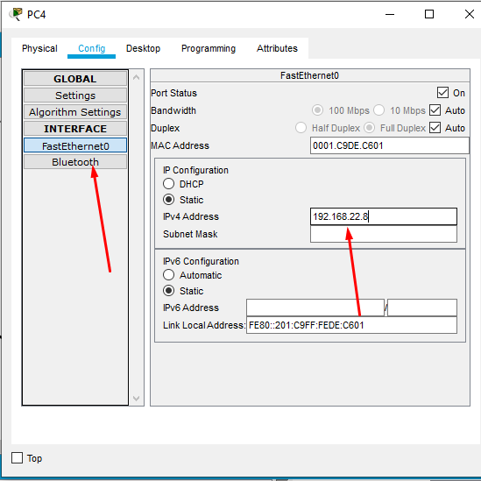

**Applying vtp modes:**

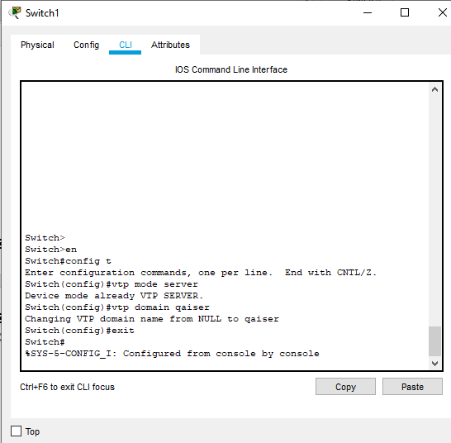

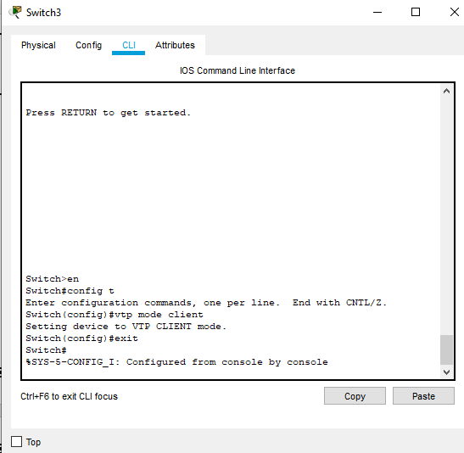

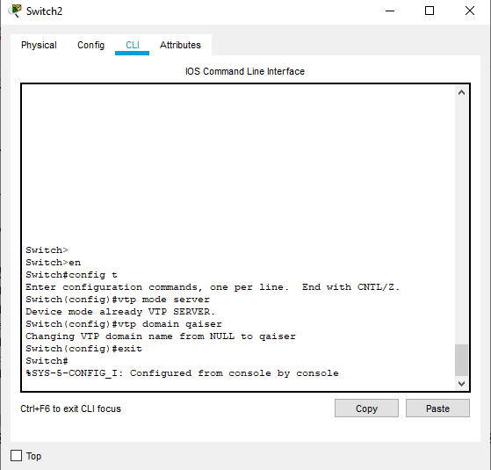

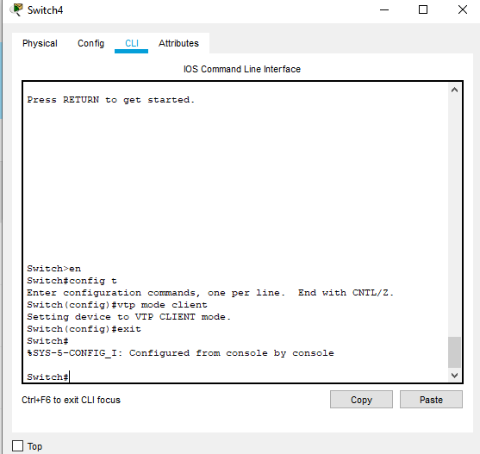

**Testing**

**Pinging pc3 from pc1**

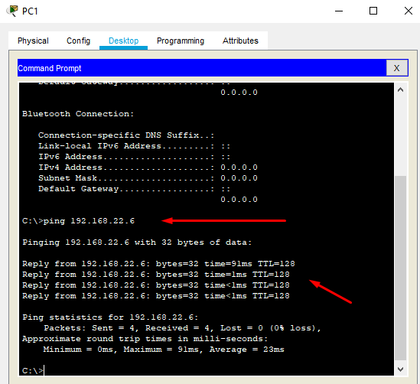

**Pinging pc 2 from pc4**

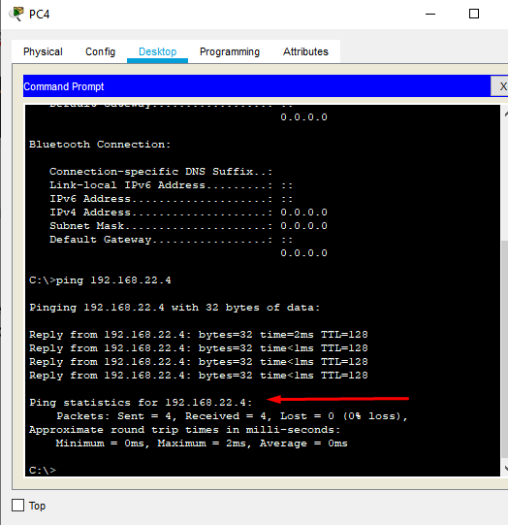

**5. Delete VLANHR from the server switch and show the impact on other switches.**

**Deleting vlan hr from server:**

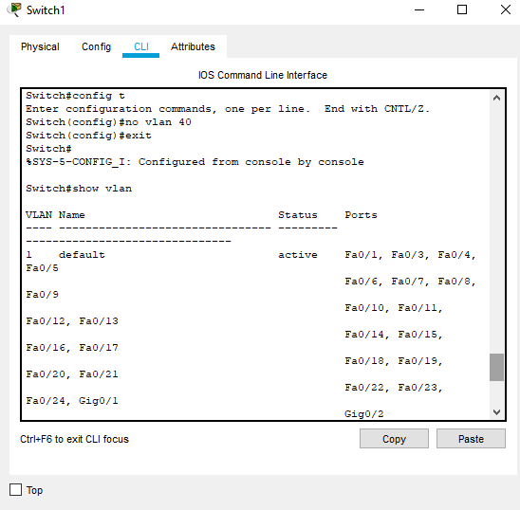

Pinging pc4 from pc 1:

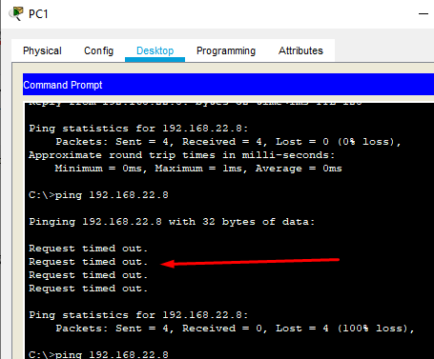

Pinging pc 3 from pc 1

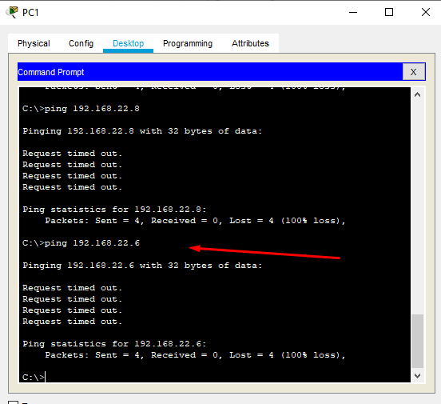

**Pinging pc3 from pc1**

